/*****************************************************************************************/

/*Project: Market Flash */

/*March 2025 */

/*Prepared by: Heike Reichert */

/*****************************************************************************************/

/****Note: Please ensure to submit Parent Tables first, then tables with related Foreign Keys ******/

/*****************************************************************************************/

--Create Table Clients;

CREATE TABLE Clients(

Client_ID VARCHAR(255) PRIMARY KEY,

Client_Name VARCHAR(255) NOT NULL,

Address VARCHAR(255) Not NULL,

Email VARCHAR(255) NOT NULL,

Phone VARCHAR(255) NOT NULL,

Contact_Details VARCHAR(255) NOT NULL,

Industry VARCHAR(255),

Contact_Start_Date DATE,

Contract_End_Date DATE)

;

-- add values;

INSERT INTO Clients

VALUES

('C1', 'Mister X','0806 Watson Drive Suite 662, Port Andrea, DE 42578-2286','zmcintyre@bauer.info', '3724028579','Barbara Walker',

'IT Solutions', '2012-05-01',' '),

('C2', 'Weaver, Garner and Ramos','2933 Ortiz Overpass Suite 099, South Douglasburgh, KY 52632-7557','oscott@gmail.com', '498.978.7718x501','Melinda Johnston',

'IT Solutions', '2015-12-05',' '),

('C3', 'Salinas-Chavez','53637 Bonnie Walk Suite 961, South Adrianaport, IA 49560','richard84@hotmail.com', '2545622603','Chelsea Hoffman',

'Pharma', '2018-03-24','2019-05-3'),

('C4', 'Salinas-Chavez','53637 Bonnie Walk Suite 961, South Adrianaport, IA 49560','richard84@hotmail.com', '2545622603','Chelsea Hoffman',

'Pharma', '2018-03-24','2019-05-03'),

('C5', 'Russell, Wilson and Rogers','27907 Deborah Hill Suite 235, Abigailbury, CO 58408','michael78@yahoo.com', '(995)213-63153','Michael Howard',

'Pharma', '2020-01-24','2021-05-31'),

('d1', 'Mister Y','Deutscher Ring 4','zmcintyre@eauer.info', '3724567579','Nathan Weber',

'Market place', '2012-05-01',' '),

('d2', 'Weaver, Garner and Sons','Berliner Platz5','deint@gmail.com', '498.978.7718x501','Christopher Riggs',

'IT Solutions', '2022-07-08',' '),

('d3', 'Salinas-Chavez','53637 Bonnie Walk Suite 961, South Adrianaport, IA 49560','hallo84@hotmail.com', '4325622603','Chelsea Hoffman',

'Pharma', '2024-05-24','2025-01-3'),

('d4', 'Salinas-Chavez','ums eck','rbin4@hotmail.com', '7893603','Kathy Mahoney',

'Pharma', '2018-03-24','2019-05-03'),

('d5', 'Russell, Wilson and Rogers','27907 Deborah Hill Suite 235, place, CO 58408','thomas78@yahoo.com', '(995)213-63153','Nathan Weber',

'Digest', '2020-11-30',' ')

;

Select * from Clients;

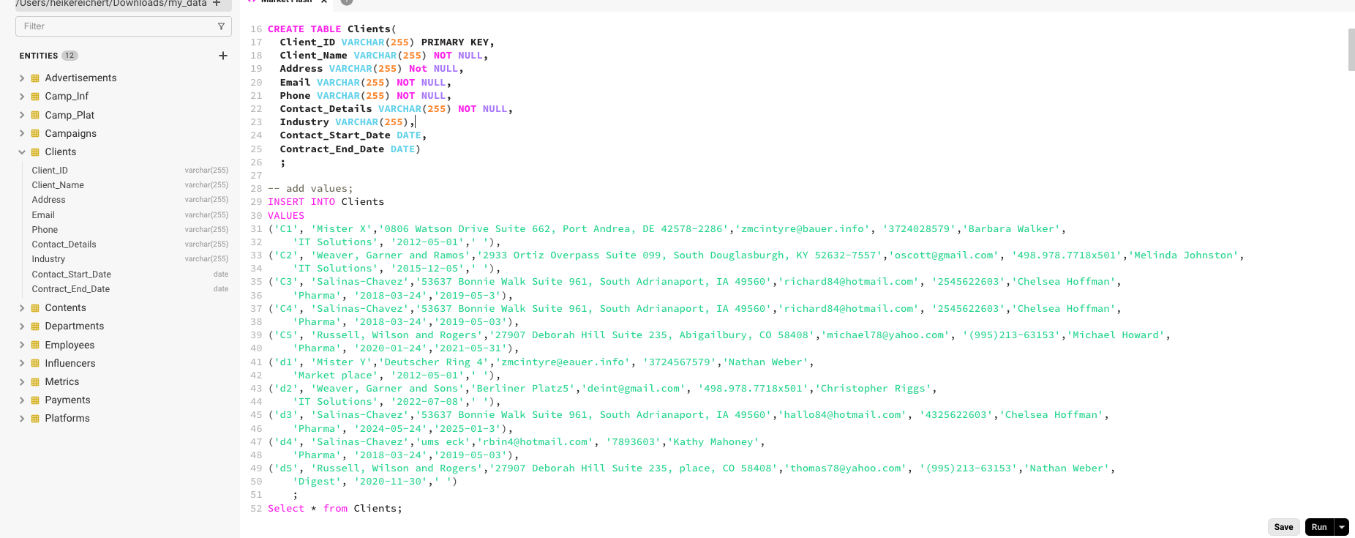

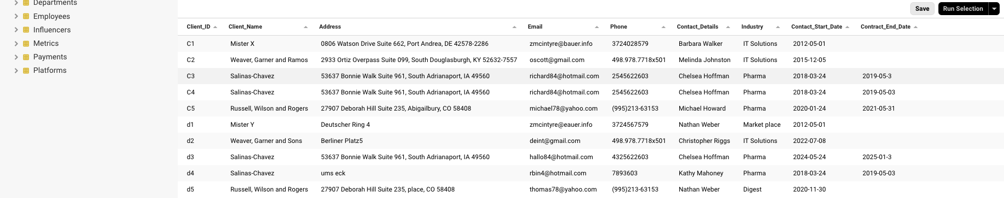

/**************************************************************************************************************************/

--Create Table Platforms

CREATE TABLE Platforms(

Platform_ID VARCHAR(255) PRIMARY KEY,

Platform_Name VARCHAR(255) NOT NULL,

URL VARCHAR(255) NOT NULL,

Contact_Person VARCHAR(255) NOT NULL,

Contact_Phone VARCHAR(255) NOT NULL,

Contact_Email VARCHAR(255) NOT NULL

)

;

-- add values;

INSERT INTO Platforms

VALUES

('P1','YouTube','https://www.youtube.com','Angela Buss','02351-4567','Amgela@ypitube'),

('P2','TikTok','https://www.tiktok.com › ...','Achim Da,','1267-543','Achim@tok'),

('P3','Instagram','https://www.instagram.com','Margy Damm,','67876-456','Margy@insta.com'),

('P4','Email','https://www.email.com','Tommy Hill,','(942) 456t67876-456','Tommy@iemail.com'),

('P5','Smart','https://www.smart.com','Lisa Schmidts,','(942) 456777876-456','Lisa@iemail.com')

;

Select * from Platforms;

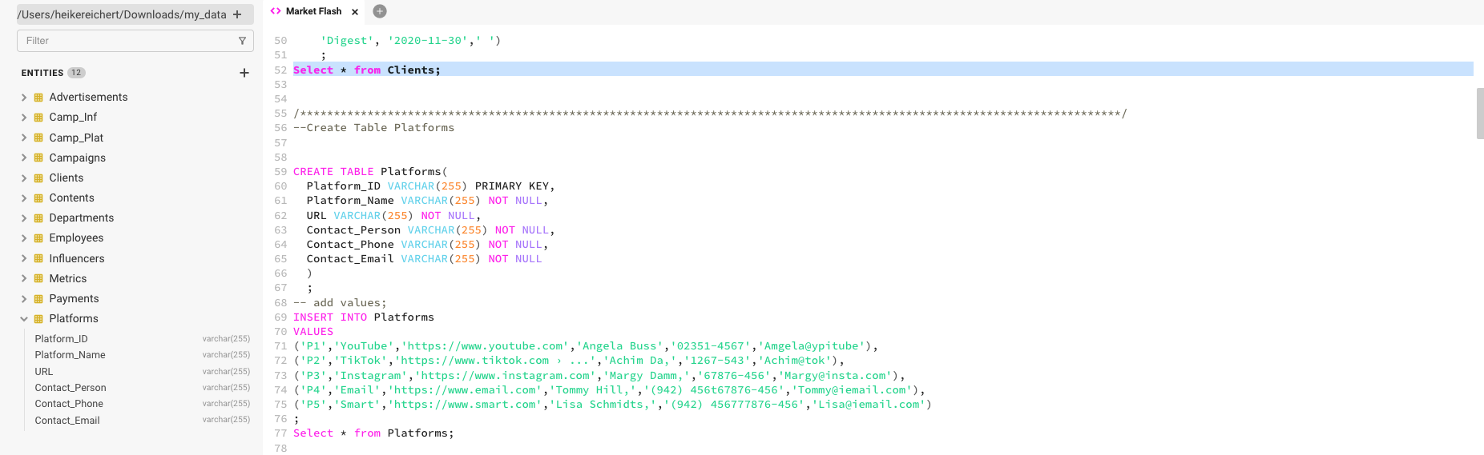

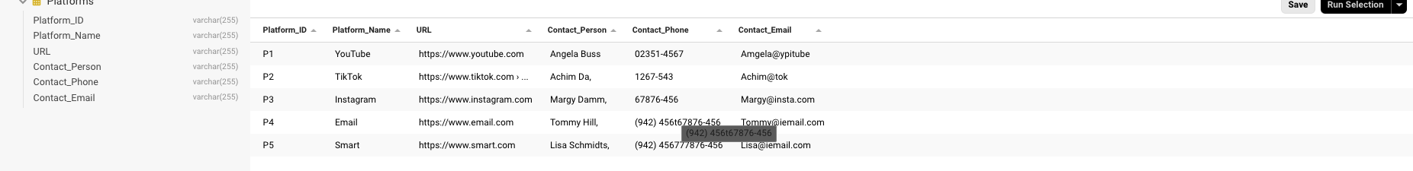

/****************************************************************************************************************/

--Create Table Camp_Plat connecting table for many:many relationships

CREATE TABLE Camp_Plat(

Camp_Plat_ID VARCHAR(255) PRIMARY KEY,

Platform_ID VARCHAR(255) ,

Campaign_ID VARCHAR(255),

FOREIGN KEY (Platform_ID) REFERENCES Platforms(Platform_ID),

FOREIGN KEY (Campaign_ID) REFERENCES Campaigns(Campaign_ID)

)

;

INSERT INTO Camp_Plat

VALUES

('P1C01','P1','C01'),

('P1C02','P1','C02'),

('P1C03','P3','C03'),

('P2C04','P2','C04'),

('P2C05','P2','C05'),

('P4C01','P4','C01'),

('P4C02','P4','C02'),

('P4C03','P4','C03'),

('P4C04','P4','C04')

;

Select * from Camp_Plat;

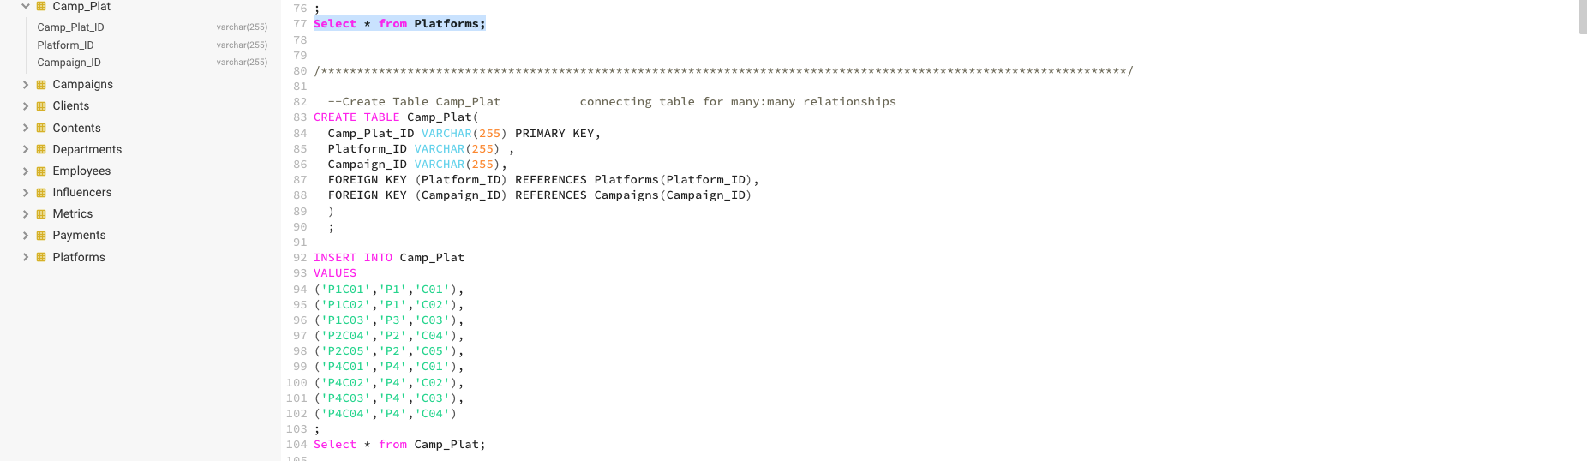

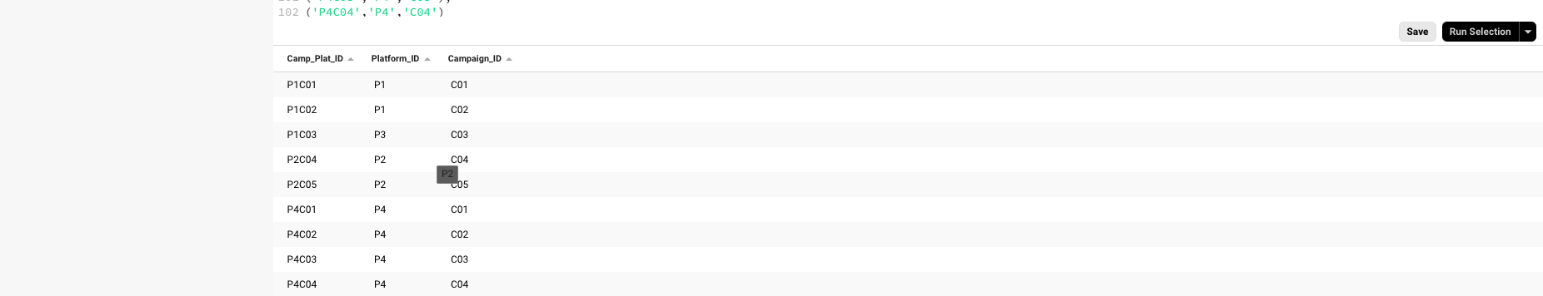

/****************************************************************************************************************/

--Create Table Influencers

CREATE TABLE Influencers(

Influencer_ID VARCHAR(255) PRIMARY KEY,

Influencer_Name VARCHAR(255) NOT NULL,

Social_Handle VARCHAR(255) NOT NULL,

Follower_Count NUMERIC,

Contact_Details VARCHAR(255)

)

;

INSERT INTO Influencers

VALUES

('I01','Albert','Al@ffff',456,'Am Berge 20, Xstadt'),

('I02','Emil','El@ffff',12456,'Hellweg 2, Yvillage'),

('I03','Anna','An@hjkl',123456787,'anna@hier'),

('I04','David','Da@f5667',6788976665,'keine Angabe'),

('I05','Albert2','Al2@ffff',3,'db@here'),

('I06','AlbertEinstein','Ael@ffff',1456,'Am Berge 222, Xstadt'),

('I07','EmilunddieDetektive','Eldet@ffff',6712456,'Hellweg 222, Yvillage'),

('I08','Anna500','An500@hjkl',999123456787,'anna@hier'),

('I09','Davidr','Da@rf5667',886788976665,'keine Angabe'),

('I10','Albert25','Al25@ffff',63,'db@here')

;

Select * from Influencers;

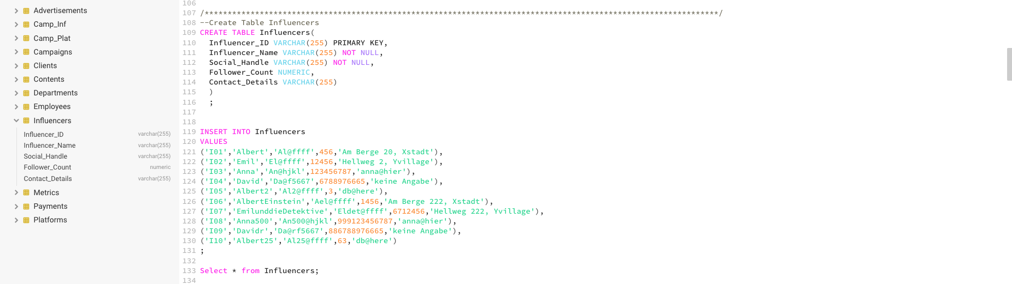

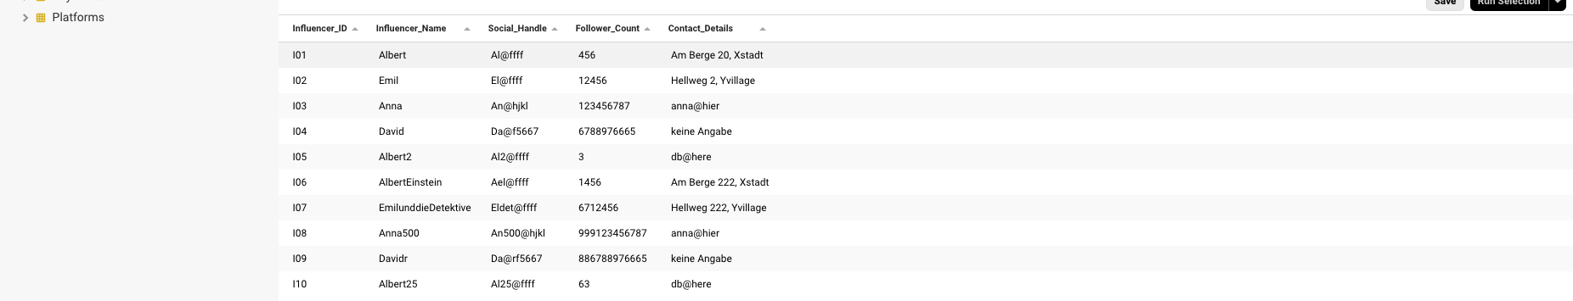

/************************************************************************************************************/

--Create Table Camp_Inf connecting table for many:many relationships

CREATE TABLE Camp_Inf(

Camp_Plat_ID VARCHAR(255) PRIMARY KEY,

Campaign_ID VARCHAR(255) ,

Influencer_ID VARCHAR(255),

FOREIGN KEY (Campaign_ID) REFERENCES Campaigns(Campaign_ID),

FOREIGN KEY (Influencer_ID) REFERENCES Influencers(Influencer_ID)

)

;

INSERT INTO Camp_Inf

VALUES

('C01I01','C01','I01'),

('C01I02','C01','I02'),

('C01I03','C03','I03'),

('C02I04','C02','I04'),

('C02I05','C02','I05'),

('C04I06','C04','I06'),

('C04I01','C04','I01'),

('C04I02','C04','I02'),

('C04I03','C04','I03'),

('C04I04','C04','I04'),

('C03I03','C03','I05'),

('C03I06','C03','I06')

;

Select * from Camp_Inf;

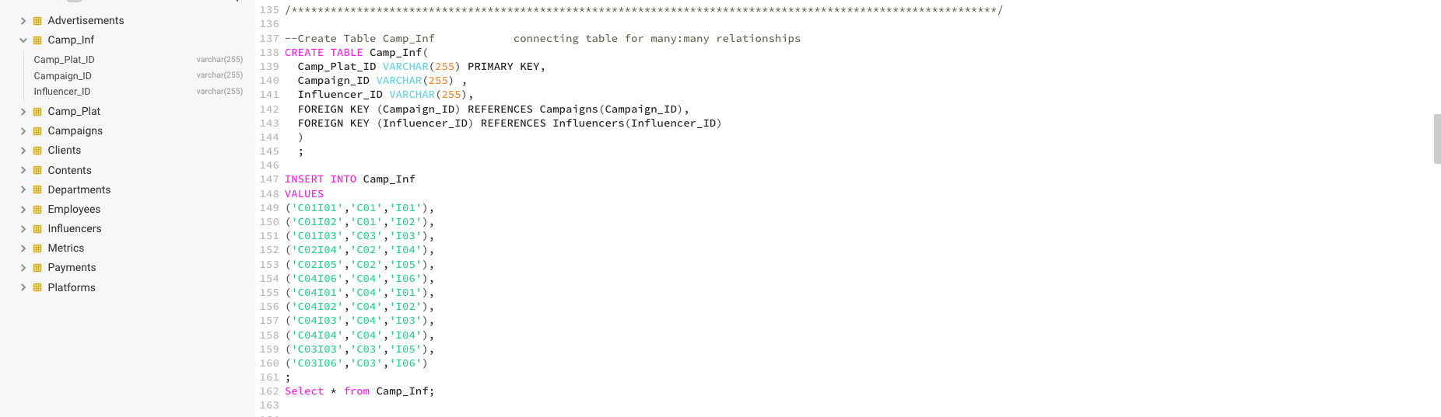

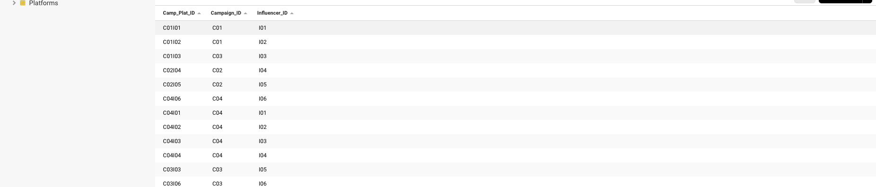

/****************************************************************************************************************/

--Create Table Advertisements

CREATE TABLE Advertisements(

Ad_ID VARCHAR(255) PRIMARY KEY,

Ad_Name VARCHAR(255) NOT NULL,

Type VARCHAR(255) ,

Duration FLOAT,

Budget FLOAT,

Campaign_ID VARCHAR(255),

Platform_ID VARCHAR(255),

FOREIGN KEY (Campaign_ID) REFERENCES Campaigns(Campaign_ID),

FOREIGN KEY (Platform_ID) REFERENCES Platforms(Platform_ID))

;

INSERT INTO Advertisements

VALUES

('AD01','Advertisement1','Social Media',25.5, 25667.1,'C01','P1'),

('AD02','Advertisement2','Social Media',55.5, 125667.1,'C02','P1'),

('AD03','Advertisement3','Social Media',6,5555667.1,'C03','P4'),

('AD04','Advertisement4','Social Media',66.5,67.1,'C04','P3'),

('AD05','Advertisement5','Social Media',75.5,5665667.1,'C01','P5'),

('AD06','Advertisement6','Social Media1',25.5, 25667.1,'C02','P1'),

('AD07','Advertisement7','Social Media2',55.5, 125667.1,'C03','P1'),

('AD08','Advertisement8','Social Media3',6,5555667.1,'C04','P3'),

('AD09','Advertisement9','Social Media4',66.5,67.1,'C05','P4'),

('AD10','Advertisement10','Social Media5',75.5,5665667.1,'C01','P4')

;

Select * from Advertisements;

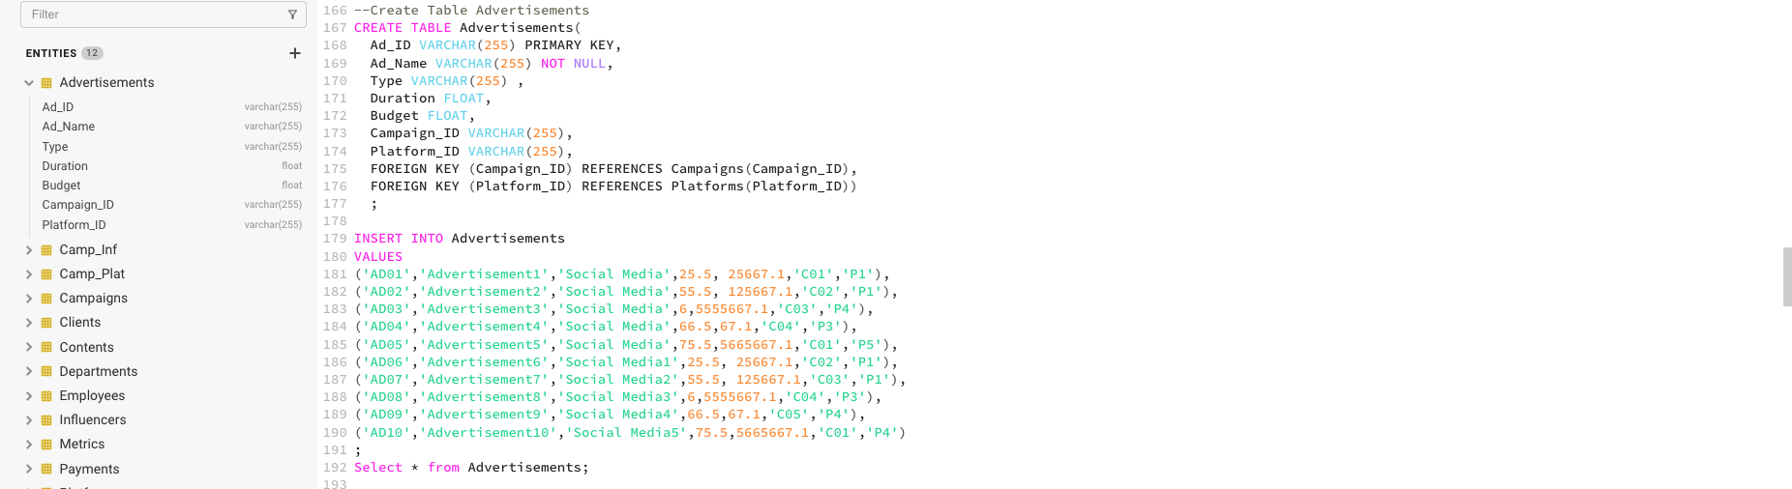

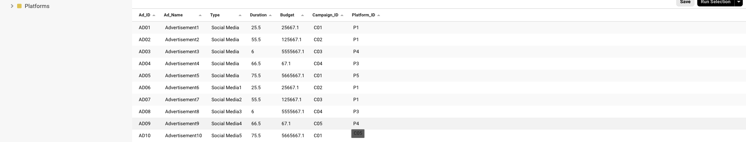

/************************************************************************************************************/

--Create Table Campaigns

CREATE TABLE Campaigns(

Campaign_ID VARCHAR(255) PRIMARY KEY,

Campaign_Name VARCHAR(255) NOT NULL,

Start_Date DATE,

End_Date DATE,

Budget FLOAT,

Client_ID VARCHAR(255),

Platform_ID VARCHAR(255),

Employee_ID VARCHAR(255),

FOREIGN KEY (Platform_ID) REFERENCES Platforms(Platform_ID),

FOREIGN KEY (Client_ID) REFERENCES Clients(Client_ID),

FOREIGN KEY (Employee_ID) REFERENCES Employees(Employee_ID)

)

;

INSERT INTO Campaigns

VALUES

('C01','Campaign1','2015-10-01','2015-11-01',15678.1, 'C1','P1','E100'),

('C02','Campaign2','2015-12-01','2015-12-30',5678.1, 'C1','P2','E1000'),

('C03','Campaign3','2020-02-01','2022-11-01',99915678.1, 'C2','P3','E1000'),

('C04','Campaign4','20195-10-01','2020-11-01',15699978.1, 'C2','P1','E100'),

('C05','Campaign5','2011-10-01','2012-11-01',156555578.1, 'C3','P4','E0')

;

Select * from Campaigns;

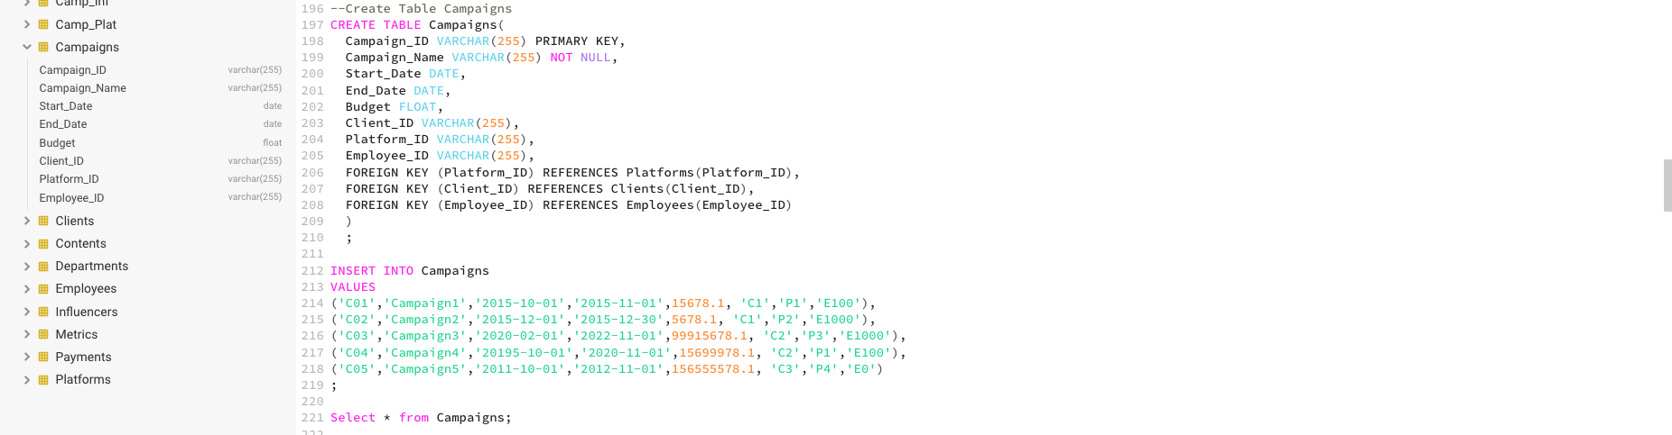

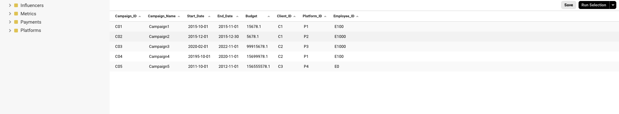

/***************************************************************************************************************/

drop table payments;

--Create Table Payments

CREATE TABLE Payments(

Payment_ID VARCHAR(255) PRIMARY KEY,

Date DATE,

Amount FLOAT NOT NULL,

Payment_Type VARCHAR(255),

Payment_Details VARCHAR(255),

Campaign_ID VARCHAR(255),

FOREIGN KEY (Campaign_ID) REFERENCES Campaigns(Campaign_ID)

)

;

INSERT INTO Payments

VALUES

('Pay01','2015-04-29',45.1, 'Credit','Master','C01'),

('Pay02','2016-01-29',2566.5, 'Credit','Master','C02'),

('Pay03','2020-02-02',456778, 'Credit','VISA','C03'),

('Pay04','2025-01-29',5671, 'Transferral','Swiss Bank','C04'),

('Pay05','2017-09-29',345678, 'ransferral','Deutsche Bank','C05'),

('Pay06','2015-04-29',45.1, 'Credit','Master','C01'),

('Pay07','2016-04-29',2566.5, 'Credit','Master','C02'),

('Pay08','2020-10-02',456778, 'Credit','VISA','C03'),

('Pay09','2025-01-05',5671, 'Transferral','Swiss Bank','C04'),

('Pay10','2017-03-29',345678, 'ransferral','Deutsche Bank','C05')

;

Select * from Payments;

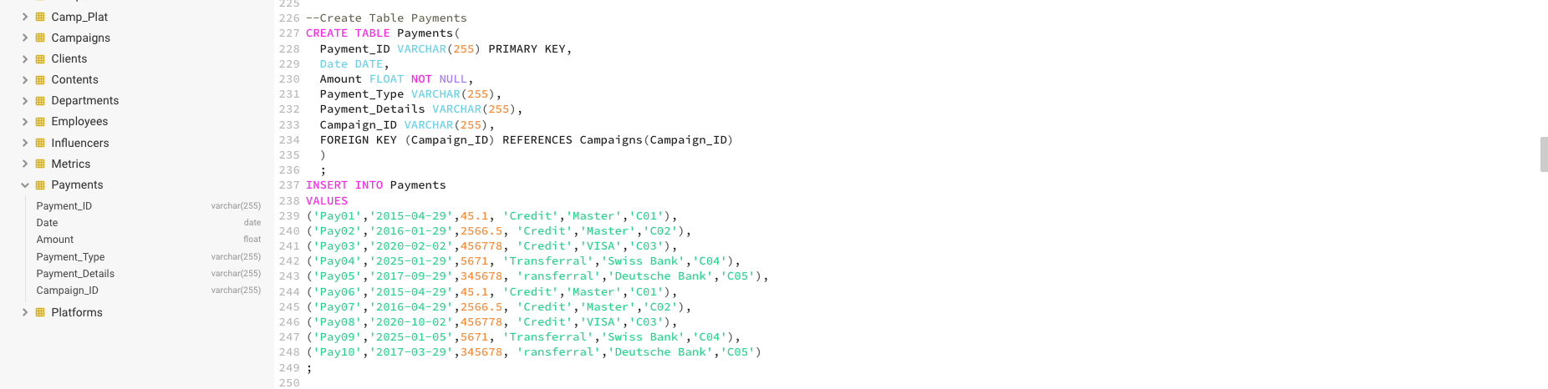

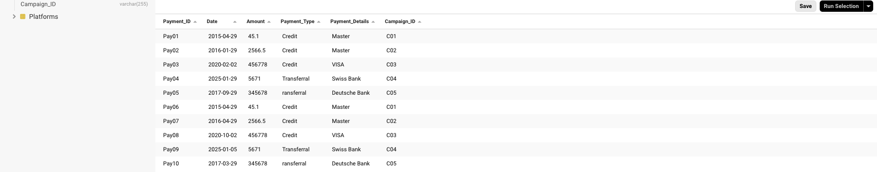

/***********************************************************************************************************/

--Create Table Employees

CREATE TABLE Employees(

Employee_ID VARCHAR(255) PRIMARY KEY,

Employee_name VARCHAR(255) NOT NULL,

Role VARCHAR(255),

Contact_Info VARCHAR(255),

Emmployee_Since DATE,

Supervisor_ID VARCHAR(255),

Department_ID VARCHAR(255),

FOREIGN KEY (Department_ID) REFERENCES Departments(Department_ID)

)

;

--FOREIGN KEY (Supervisor_ID) REFERENCES Employees(Employees_ID),

INSERT INTO Employees

VALUES

('E','Chefe','Chefe','chefe@gmx','2001-01-01','E0','D01'),

('E0','dumpy','CEO','Dumpy@gmx','2001-01-01','E0','D01'),

('E00','Tom Maier','Department Chef - Sales','maier@gmx','2001-01-01','E0','D01'),

('E100','John Doe','Department Chef - HR','Doe@gmx','2001-01-01','E0','D02'),

('E1000','Mister Smith','Department Chef - R&D','Schmidt@gmx','2001-01-01','E0','D03'),

('E100000','Muller','Department Chef - Laboratory 1','Mueller@gmx','2001-01-01','E0','D04'),

('E200000','Carter','Department Chef - Laboratory 2','Carter@gmx','2001-01-01','E0','D05'),

('E300000','Bee','Department Chef - Laboratory 3','Mueller@gmx','2001-01-01','E0','D06'),

('E01','Buss','Sales Representative','Buss@gmx','2001-01-01','E00','D01'),

('E03','Martin','Sales Representative','Martin@gmx','2001-01-01','E00','D02'),

('E101','Kind','R&D admin','Kind@gmx','2001-01-01','E100','D03'),

('E1001','Smith','Laborian','Smith@gmx','2001-01-01','E1000','D04')

;

Select * from Employees;

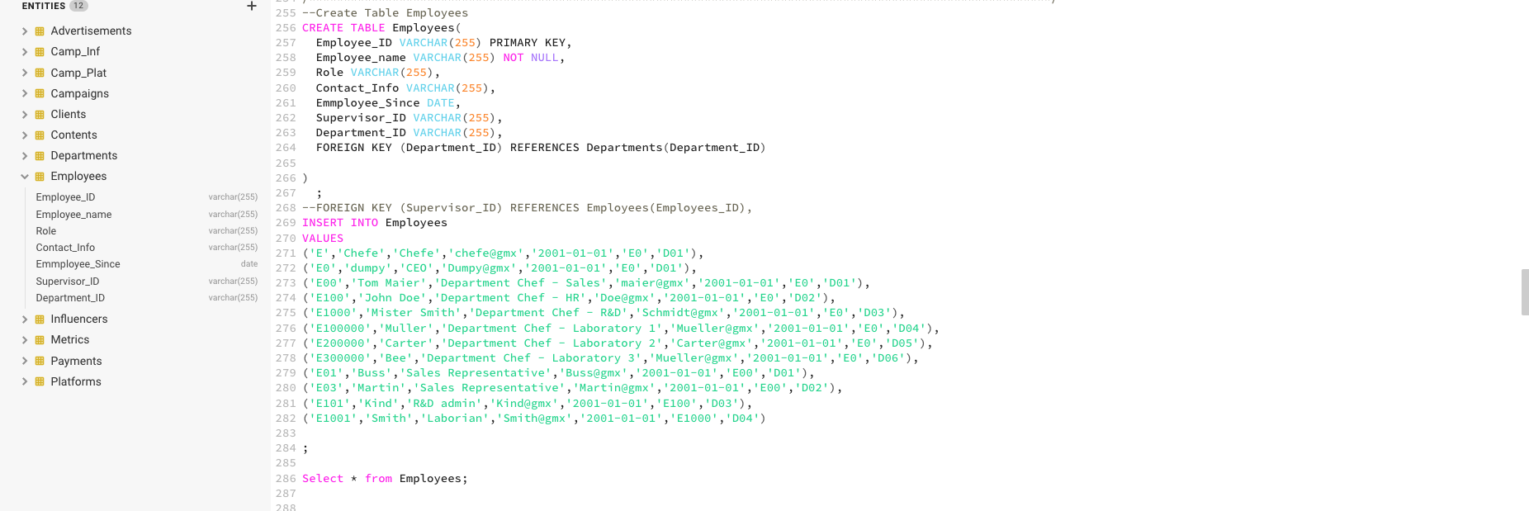

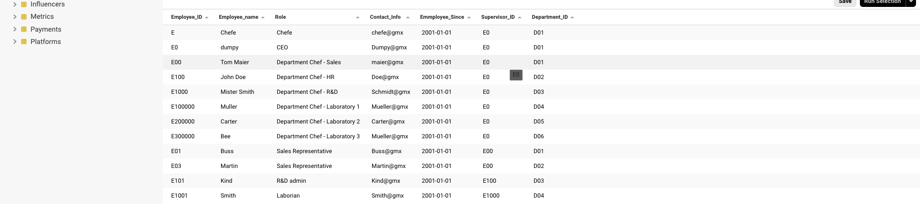

/************************************************************************************************************/

--Create Table Departments

CREATE TABLE Departments(

Department_ID VARCHAR(255) PRIMARY KEY,

Department VARCHAR(255) NOT NULL

)

;

INSERT INTO Departments

VALUES

('D01','Sales' ),

('D02','HR' ),

('D03','R&D' ),

('D04','Laboratory 1' ),

('D05','Laboratory 2' ),

('D06','Laboratory 3' )

;

Select * from Departments;

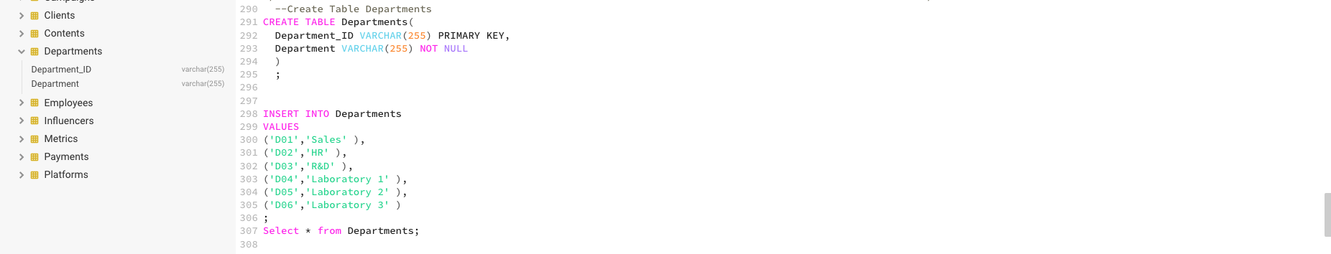

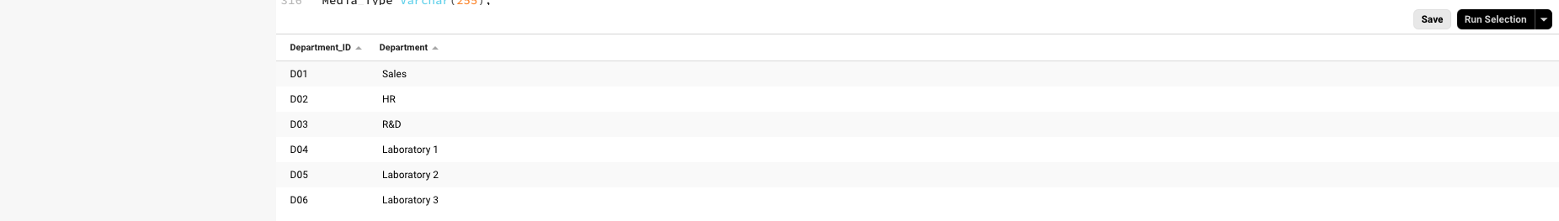

/**************************************************************************************************************/

--Create Table Contents

CREATE TABLE Contents(

Content_ID VARCHAR(255) PRIMARY KEY,

Title VARCHAR(255) NOT NULL,

Description Varchar(255),

Media_Type Varchar(255),

Creation_Date DATE,

Campaign_ID VARCHAR(255),

FOREIGN KEY (Campaign_ID) REFERENCES Campaigns(Campaign_ID)

)

;

INSERT INTO Contents

VALUES

('Cont1','Content1','Description1','Internet','2015-12-01','C01'),

('Cont2','Content2','Description2','Internet','2013-12-01','C02'),

('Cont3','Content3','Description3','Newspaper','2009-12-01','C02'),

('Cont4','Content5','Description4','cinema','2015-05-01','C04'),

('Cont5','Content6','Description6','Internet','2015-12-01','C01')

;

Select * from Contents;

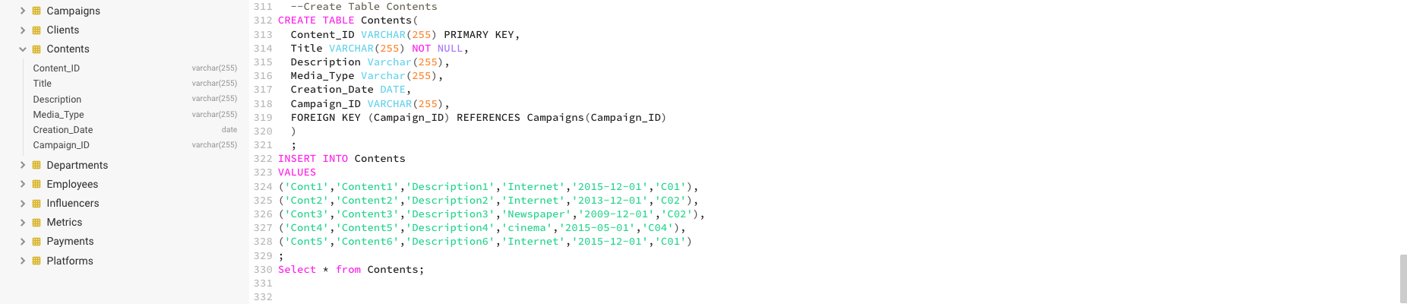

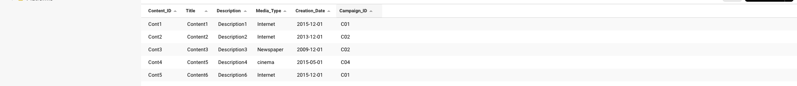

/************************************************************************************************************/

--Create Table Metrics

CREATE TABLE Metrics(

Metric_ID VARCHAR(255) PRIMARY KEY,

Audience VARCHAR(255) ,

Location VARCHAR(255),

Impressions NUMERIC,

Clicks NUMERIC,

Engagement NUMERIC,

Conversion_Rate FLOAT,

Campaign_ID VARCHAR(255),

FOREIGN KEY (Campaign_ID) REFERENCES Campaigns(Campaign_ID)

)

;

INSERT INTO Metrics

VALUES

('M01','Adults','Germany',15,5,50,5.6,'C01'),

('M02','18-25','US',25,15,150,15.6,'C02'),

('M03','12-16','France',35,25,250,25.6,'C03'),

('M04','Adults','Germany',45,35,350,35.6,'C04'),

('M05','<18','Belgium',55,45,450,45.6,'C05')

;

Select * from Metrics;

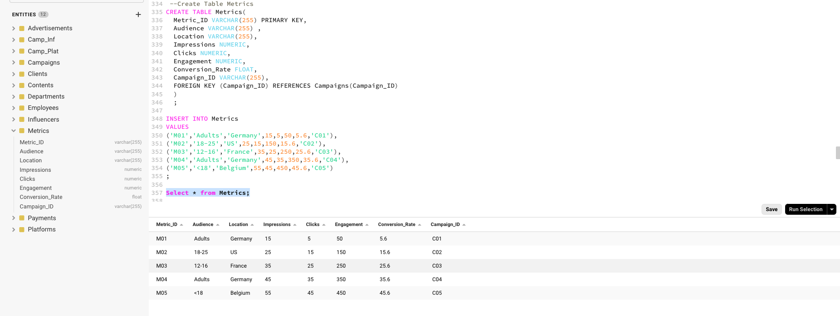

/**************************************************************************************************/

/* Check Database */

/**************************************************************************************************/

/* 1. Campaign - payments */

select *

from Campaigns c

left join Payments p on c.Campaign_ID = p.Campaign_ID

;

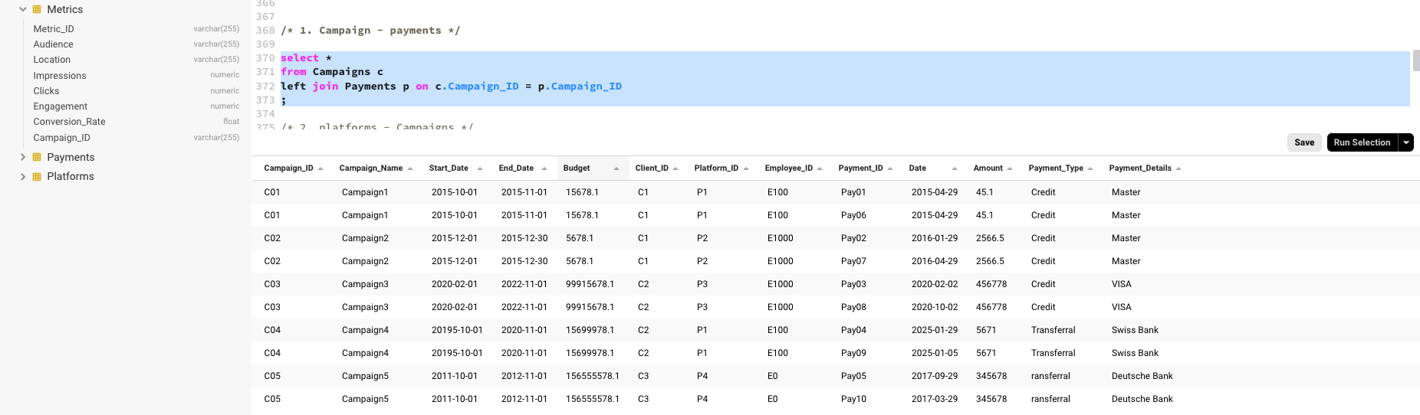

/* 2. platforms - Campaigns */

select *

from Campaigns c

left join camp_plat cp on c.Campaign_ID = cp.campaign_ID

left join Platforms p on cp.platform_id = p.Platform_ID

;

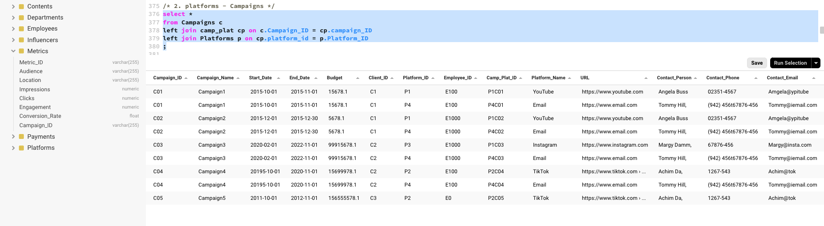

/* 3. influencer - campaigns */

select *

from Campaigns c

left join camp_inf ci on c.Campaign_ID = ci.campaign_ID

left join Influencers i on ci.Influencer_id = i.Influencer_ID

;

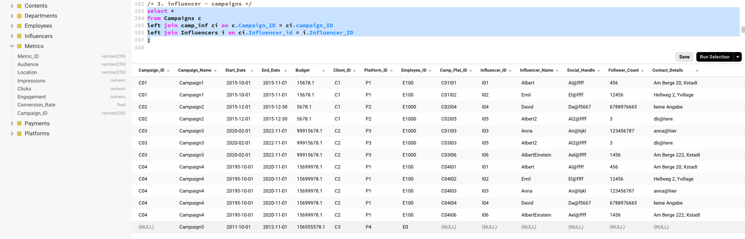

/* 4. Clients - campaigns */

select *

from Campaigns c

left join clients cl on c.client_ID = cl.client_id

;

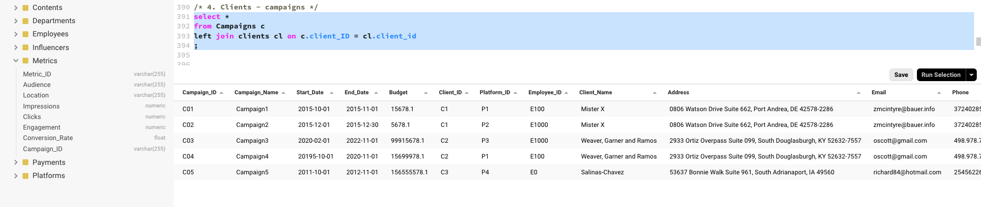

/* 5. advertisement - campaign */

select *

from Campaigns c

left join advertisements a on c.Campaign_ID = a.Campaign_ID

;

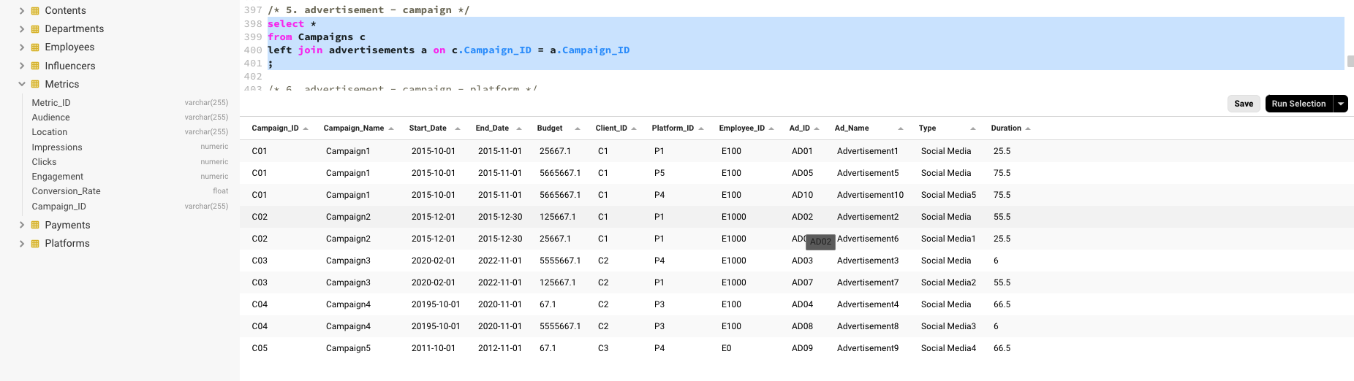

/* 6. advertisement - campaign - platform */

select *

from Campaigns c

left join camp_plat cp on c.Campaign_ID = cp.campaign_ID

left join Platforms p on cp.platform_id = p.Platform_ID

left join Advertisements a on a.Platform_ID = p.Platform_ID

;

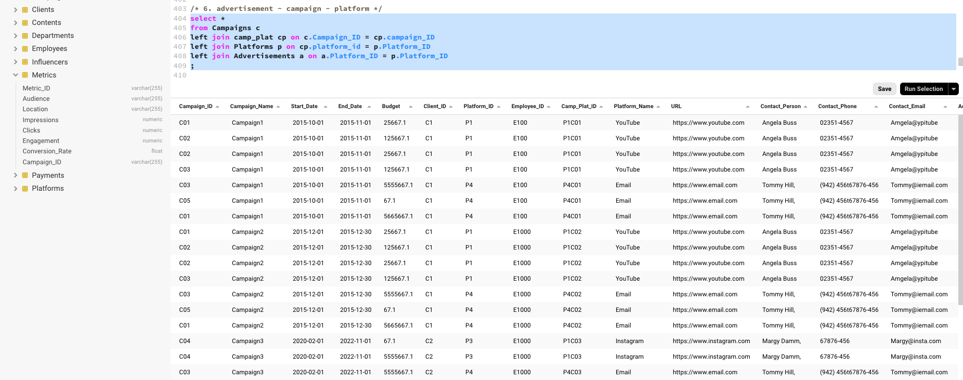

/* 7.Advertisements - campaing - platforms - clients */

select *

from Campaigns c

left join camp_plat cp on c.Campaign_ID = cp.campaign_ID

left join Platforms p on cp.platform_id = p.Platform_ID

left join Advertisements a on a.Platform_ID = p.Platform_ID

left join clients cl on cl.client_id = c.Client_ID

;

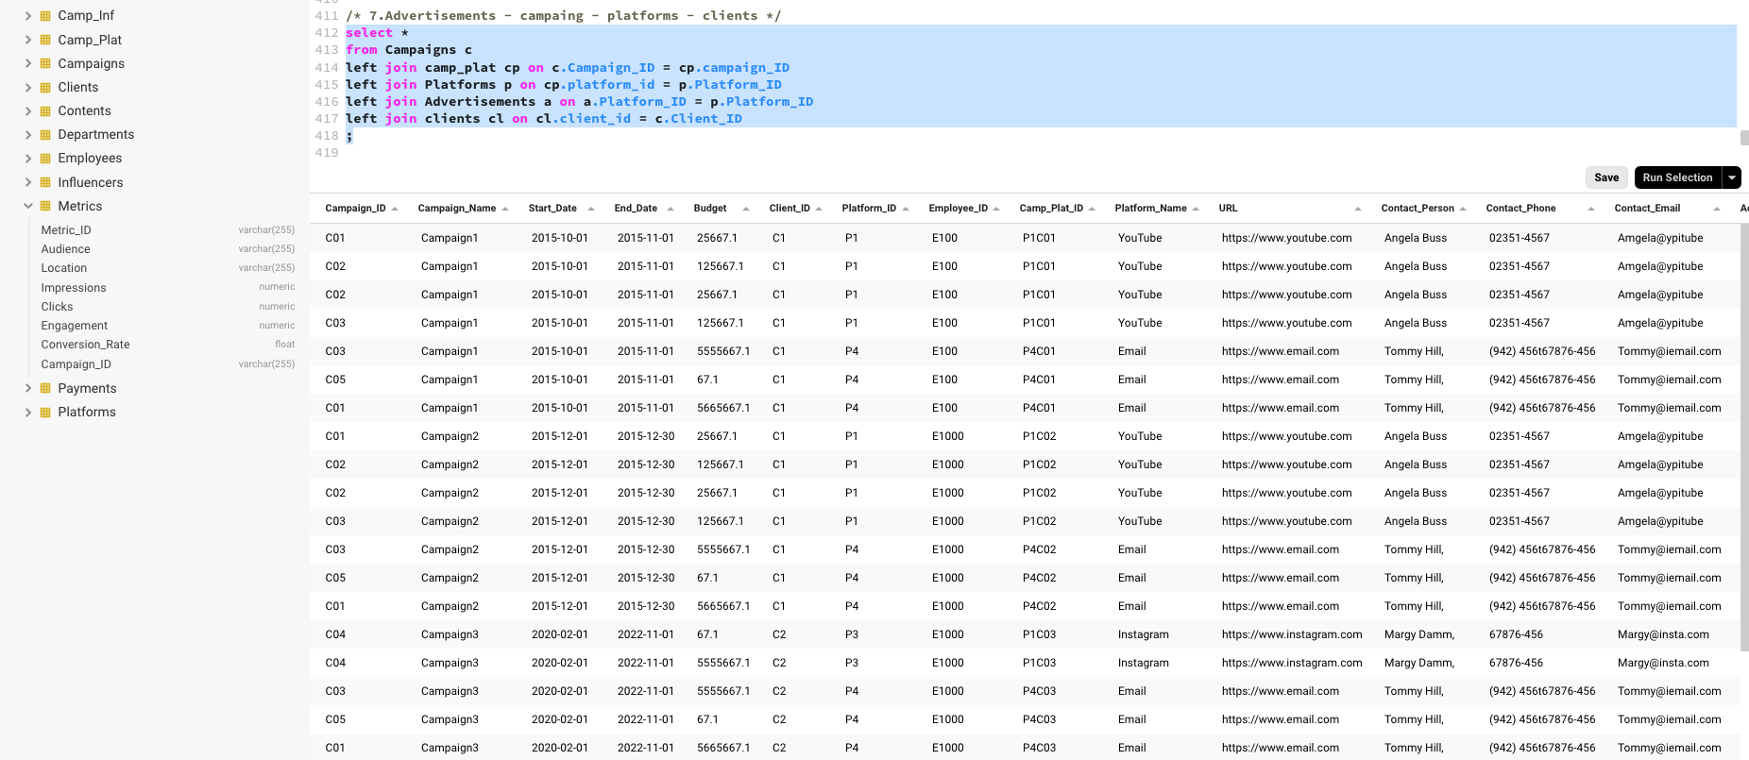

/* 8.Advertisements - campaing - platforms - clients - employees*/

select *

from Campaigns c

left join camp_plat cp on c.Campaign_ID = cp.campaign_ID

left join Platforms p on cp.platform_id = p.Platform_ID

left join Advertisements a on a.Platform_ID = p.Platform_ID

left join clients cl on cl.client_id = c.Client_ID

left join employees e on e.employee_id = c.Employee_ID

;

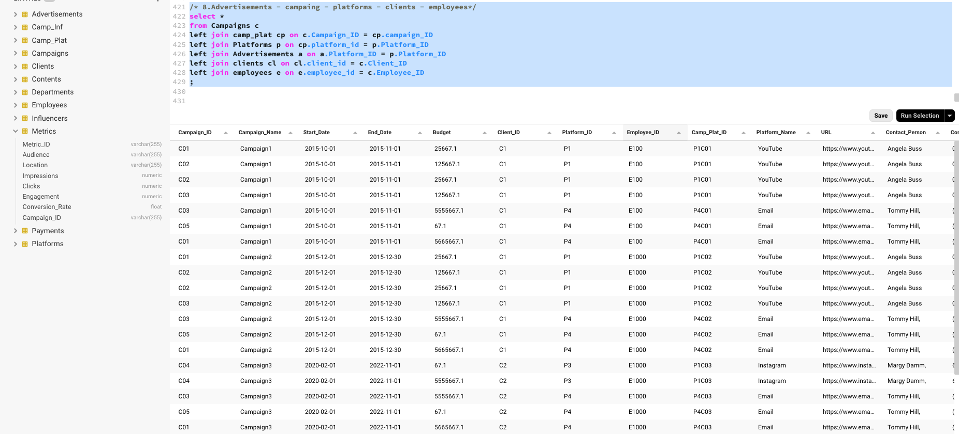

/* 9.campaigns - contents */

select *

from Campaigns c

left join contents ct on c.Campaign_ID = ct.Campaign_ID

;

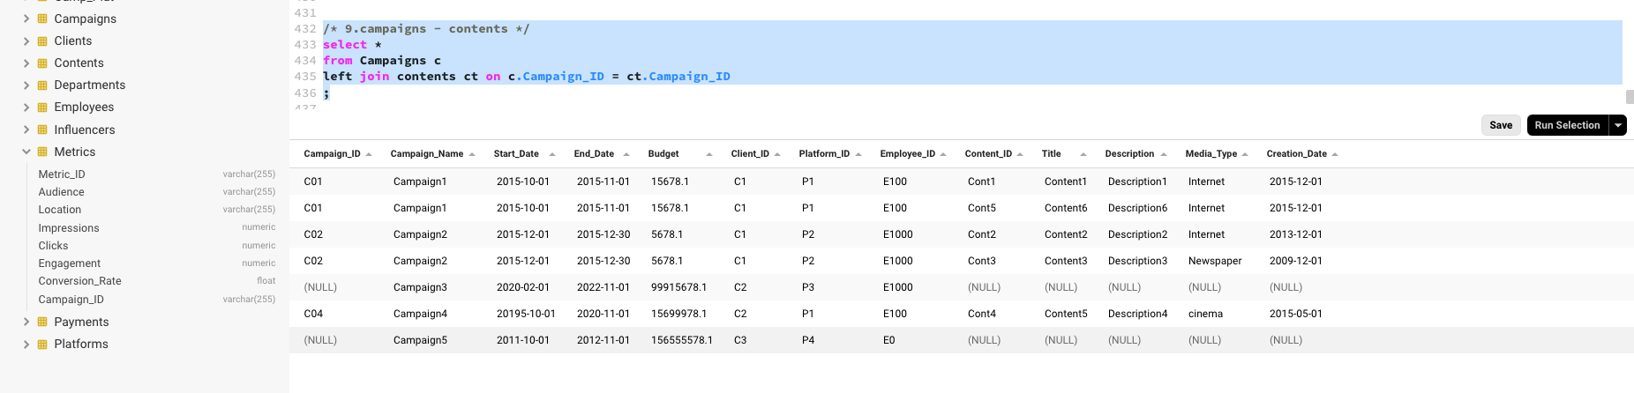

/* 10. campaigns - metrics */

select *

from Campaigns c

left join metrics m on c.Campaign_ID = m.Campaign_ID

;

